A Reliability-Aware Explainable AI System for Cardiovascular Disease Detection and Diagnosis
Anonymous Author(s)
Affiliation withheld for double-blind review

Abstract—A machine-learning model placed in a clinical workflow returns a probability, and the software around it usually treats every probability as equally trustworthy. Our measurements say otherwise. We present a decision-support system over chest radiographs, 12-lead electrocardiograms, echocardiogram video and emergency-department triage records, in which each component carries an explicit rule for declining to answer and each rule is tested against a control. On radiographs, a covariate stored in the image metadata costs 0.0639 AUROC; group-wise thresholds cut the reported true-positive-rate disparity by 73.3 % at no cost in AUROC, and group-conditional deferral closed a 6.68 point accuracy gap to within sampling noise of zero, where uniform deferral did not. On electrocardiograms, a conformal layer gives rule-in and rule-out decisions under a stated miss-rate bound that holds for the population and fails inside 9 of 23 sex and age subgroups, which group-conditional calibration repairs in 22 of 23. On echocardiograms, ordinal supervision derived from the label's own measurement noise reaches 3.979 points of mean absolute error and 0.723 worst-class recall under an 11 to 1 imbalance. On triage records, admitting a feature only when it existed at the decision time gives AUROC 0.9560 at 99.41 % negative predictive value. Four further ablations turn the same standard on our own design choices, and three come back negative, including a network component of ours that costs 0.0042 macro-AUROC.
Index Terms—abstention, ablation, chest radiography, class imbalance, clinical decision support, conformal prediction, covariate shift, data leakage, echocardiography, electrocardiography
I. Introduction
A patient who arrives at an emergency department with chest pain generates four very different kinds of data within a day. A triage nurse records vital signs and a free-text complaint. An electrocardiogram is recorded within ten minutes [1], because a blocked artery has to be found before any blood test can come back. A chest radiograph is taken early, mainly to rule out causes that are not cardiac at all [2]. Blood is drawn and repeated, and an ultrasound scan of the beating heart is booked. Each has become a machine-learning problem in its own right, and in each case the published result is normally one accuracy figure on one dataset.
One figure is a poor description of a model that is about to sit behind an API. It says nothing about the inputs on which the model is weakest, and here those inputs are not rare corner cases. We measured four. Our chest-radiograph classifier is 0.0639 AUROC worse on images taken at the bedside than on images taken standing, a covariate shift driven by a field in the image metadata; the bedside view is used when the patient is too ill to stand, so the model is weakest on the sickest patients. A conformal guarantee on our electrocardiogram classifier holds over the test set as a whole and fails inside 9 of 23 sex and age subgroups. Our echocardiogram model is weakest on the most severe cases, 5.9 % of the training data. And a triage model can look excellent because it read a feature that did not exist yet: in the raw records that blood test was taken a median of 21.75 hours after the decision it claims to support. That one is not hypothetical. An audit of an earlier version of our own triage component found it reading its label out of a comorbidity column, and we rebuilt it from the raw tables.
These four problems have separate literatures, but the engineering response is the same each time: the model has to expose when it should not be believed, in a form the calling code can branch on. So we built each component around a rule that declines to commit, tested that rule against a control which keeps the procedure and removes the signal, and reduced the four rules to one field at the service boundary. We then turned the same discipline on our own design choices. The contributions are:
• four detection models, one per modality, each carrying an abstention rule fitted on validation data and frozen before the test split was opened;
• one measured failure mode per modality, each with a control arm: acquisition shift, subgroup validity of a conformal guarantee, silent input corruption, inputs outside the label space, tail shrinkage under imbalance, and temporal leakage;
• four ablations of our own design decisions, three of them negative results we report rather than bury, including one network component that measurably costs accuracy;
• a reliability contract mapping four incompatible vocabularies onto five actionability levels, and a gated six-stage traversal over it.
II. Related Work
Each modality has an established model family: convolutional classification over MIMIC-CXR [3] with a ConvNeXt backbone [4] and a BioBART decoder [5]; one-dimensional residual networks over PTB-XL [6]; video regression on EchoNet-Dynamic [7] with an R(2+1)D backbone [8], with CAMUS [9] as a smaller cohort richer in severe cases; and gradient-boosted trees [10] with post-hoc attribution [11] over emergency-department tables [12]. Saliency is usually Grad-CAM [13].
The reliability side has its own literature, which we use rather than reinvent. Subgroup performance gaps are well documented [14]; equal opportunity [15] is the usual metric, and fitting one threshold per group is the post-processing method proposed alongside it, so on this axis we claim the measurement and not the technique. The common alternative is to train the offending factor out of the representation, for instance with label-conditional gradient reversal [16]. A separate line lets the model abstain, from the reject option [17] to conformal prediction, which turns a score into a decision carrying a finite-sample bound [18], [19], usually after calibration [20]. Closest to our deferral result is [21], which shows abstention can widen group disparities; that is what our uniform-deferral control does, and the gap to the group-conditional version is our result. Ordinal targets use rank-consistent heads [22], and long tails with deferred re-weighting [23]. Leakage, using information unavailable at prediction time, was formalised for data mining in general [24].
What we did not find was these ideas used together, across more than one modality, with every mechanism checked against a null arm and the guarantee reported other than marginally.
III. System Architecture
The system is four models behind one FastAPI process and one web console (Fig. 1). The four share no predictions and no features, since a cardiomegaly probability and an ejection fraction have nothing in common. What they share is the contract in Section IV-E.
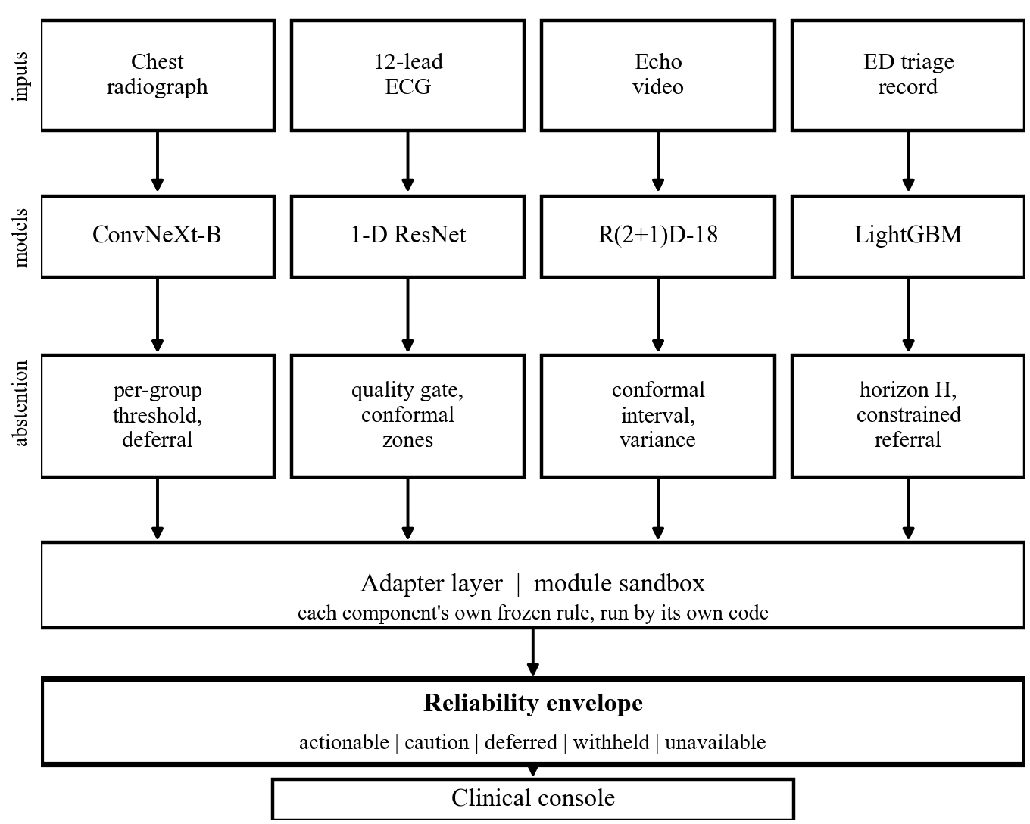
Fig. 1. System architecture. Each component keeps its own weights and its own frozen decision rule; the service applies that rule using the component's own code and normalises the outcome.
Getting four independently written codebases into one process was not free. Their top-level module names collide, so a plain import hands one component another's configuration object and the first symptom is a wrong number rather than an exception. Each therefore runs inside a module sandbox that installs its own search path and then lifts its modules back out, asserting that every name resolved to the intended owner. No component logic is reimplemented in the service: thresholds, calibration maps, conformal bounds and decision rules are read from each component's frozen artefacts and applied by its own code.
Above the four adapters sits a traversal engine that walks one patient through six stages in the order the tests are actually done: triage on arrival, electrocardiogram within ten minutes [1], radiograph as the rule-out step [2], triage again when the blood test returns, the ultrasound, and triage once more at the end. Three results end the walk early because they make the remaining tests pointless, and every routing decision records the values it rests on. A stage with no study is marked not supplied, never read as a negative finding.
The multi-modal endpoint aggregates rather than fuses: it reduces the four verdicts to their worst case and claims no joint performance. That restraint is measured. Of the six cohort pairs only radiograph and triage are linkable, both deriving from MIMIC-IV, sharing 19,979 patients or 81.6 % of the radiograph cohort; the other five share zero by construction, since PTB-XL, EchoNet-Dynamic and CAMUS come from different hospitals, countries and decades. A patient-level four-modality dataset cannot be built from these sources, so no fusion model was trained.
IV. Methods
A. Covariate Shift from Acquisition Metadata
A ConvNeXt-Base backbone [4] with a two-layer head produces eight sigmoid outputs from a 384 by 384 image, standardised per image rather than with ImageNet statistics, which are wrong for a single-channel radiograph. Grad-CAM [13] is taken at the last feature block, and a BioBART decoder [5] over 144 visual tokens writes a draft report. The interesting part is not the network. Every radiograph carries a metadata field g in {AP, PA} recording how it was taken; the two groups are not the same distribution, so one operating point for both is a modelling error. Following [15], we fit one per group on validation data only,
τ_g = arg max_τ F1( y_g , [ p_g ≥ τ ] ) , (1)
and apply the threshold belonging to the image's own group at inference. Ranking quality cannot change under (1), because AUROC is computed over the whole ordering and cutting each group at a different point reorders nothing; we checked numerically, and the AUROC difference was zero to twelve decimal places. On top of the threshold, a selective rule hands the case to a radiologist when the prediction sits too close to the operating point,
m = | p − τ_g | , answer if m ≥ q_g , otherwise refer, (2)
with q(AP) and q(PA) fitted on validation under one shared coverage budget, choosing the pair that minimises the absolute accuracy difference between groups, and then frozen. At the deployed 85 % coverage target they are 0.2247 and 0.0029, so the system is far more reluctant to commit on the weaker group. An image with no projection field falls back to the global threshold.
B. A Guarantee, and Two Ways It Silently Stops Holding
A quality gate checking shape, duration, dead leads, units, amplitude, noise and rhythm runs before the classifier, so a rejected recording never produces a probability. Accepted recordings are band-pass filtered from 0.5 to 40 Hz with a 50 Hz notch, resampled to 500 Hz and normalised per lead, then classified by a one-dimensional residual network with squeeze-and-excitation and attention pooling, followed by per-class temperature scaling [20]. A triage layer turns each calibrated probability into one of three decisions under a training-conditional, or PAC, conformal bound [18]. For a class with n calibration positives, miss-rate budget α and confidence δ, the order statistic is
m* = max { k ≤ n : F_Beta( α ; k , n − k + 1 ) ≥ 1 − δ } , (3)
since the coverage of the k-th order statistic follows Beta(k, n−k+1). The rule-out threshold is the m*-th smallest calibration score among positives, the rule-in threshold its mirror over the negatives at a false-alarm budget β, and anything between them is referred. A class with too few calibration positives is reported as unattainable rather than approximated. Two models are served side by side, each with its own calibrator and thresholds, and a class is ruled out only when both rule it out; the merged rule-out set is their intersection, so the merged miss rate is bounded by the tighter single-model bound, at the cost of more referrals.
A bound like this is conditional on assumptions the input can break without looking broken, so two checks withdraw the guarantee while leaving the prediction in place. The first flags a swapped pair of limb electrodes, an exact linear map of the standard lead definitions, from the polarity of one lead and the inversion of another; the second asks whether the rhythm is inside the label space at all, from a beat-interval irregularity score thresholded on validation at a 5 % false-positive budget. Either way the probabilities are still returned and only the sentences promising a bounded miss rate are suppressed. A final gate checks each generated sentence against the numbers that produced it.
C. Ordinal Targets, Noisy Labels and a Long Tail
An R(2+1)D-18 backbone [8] pretrained on Kinetics-400 takes 32-frame clips of 112 by 112 pixels in two channels, grey level and a temporal difference, with four heads: regression, an ordinal cumulative head, an auxiliary class head and a log-variance head. The class boundaries at 30, 40 and 55 are clinical conventions, and the label they cut is itself noisy, since two human readers typically disagree by about 4 points. Treating it as exact throws information away, so the ordinal targets are soft,
s_k = 1 − Φ( ( t_k − e ) / σ ) , (4)
where e is the recorded value, t_k the k-th boundary, σ = 4 and Φ the standard normal distribution function, so s_k is the probability that the true value lies above t_k given a noisy measurement. Rank consistency is structural instead of repaired afterwards, unlike [22]: one severity score is compared against cut-points that increase by construction, because each gap is a softplus,
c_1 = a , c_k = a + Σ_{j<k} softplus( g_j ) , z_k = f(x) − c_k , (5)
so the cumulative probabilities can never cross. Training uses a class-balanced sampler with deferred re-weighting [23] from epoch 15 and an exponential moving average of the weights. The second cohort is intensity-matched before being mixed in, because a balanced sampler over-draws from it and would let the network use scanner brightness as a shortcut for severity. A regressor on a skewed target also shrinks predictions towards the mean, pushing the severe tail over the boundary at 30, so an expansion is fitted on validation and applied without touching the weights,
ê' = ȳ + κ ( ê − x̄ ) , κ = sd(y) / sd(ê) , clipped to [1.0, 1.7], (6)
after which the boundaries are re-optimised on validation with a lexicographic objective: worst-class recall, then balanced accuracy, then macro-F1, then closeness to the clinical value. At inference a study is sampled into ten clips and averaged over three seeds, and the interval is split-conformal, widened by the learned aleatoric term and by disagreement between clips.
D. An Information-Availability Contract
The rebuild of this component started from the leak described in Section I, so every feature now declares an availability time a(f) relative to arrival. At a disclosure horizon H the admitted feature set is
F_H = { f : a(f) ≤ H } , (7)
and values are clipped to those recorded within H hours. The same cohort, split and code are featurised at H = 0, 6 and 24 hours, making accuracy against time a reported axis rather than an unstated assumption. Detection is a gradient-boosted tree ensemble [10]; subtyping uses one four-class model instead of a cascade, since a cascade compounds error, a patient the screen misses never being recoverable later. The operating point is a stated optimisation rather than a hand-tuned multiplier,
w* = arg max_w macroF1( arg max_k w_k p_k ) s.t. min_k recall_k(w) ≥ ρ , (8)
with the recall floor ρ = 0.75, solved on validation over bootstrap resamples and then frozen. A case whose top-two margin falls below the (1 − C) quantile of the validation margins is referred to a clinician instead of being subtyped. Results are reported on the intended-use population, meaning visits with a cardiac complaint or an early electrocardiogram order; both are observable at triage, so this is selection, not leakage. A separate head asks which wall of the heart the infarct involves. That label is absent from the processed tables and was rebuilt from diagnosis codes, which needs both the ICD-9 and ICD-10 vocabularies since the cohort straddles the transition almost evenly.
E. One Reliability Contract
The four mechanisms speak four vocabularies: an acquisition group and a deferral margin; a conformal zone and a withdrawn guarantee; a prediction interval and two kinds of variance; a disclosure horizon and a referral. The service maps them onto one enumerated field: actionable when the component stands behind the result, caution when it stands but measured reliability is lower for this input, deferred when it declines to commit, withheld when output was suppressed after a quality or verification failure, and unavailable when it could not run. A client then applies one rule, do not act on a result that is not actionable, without knowing anything about projections, conformal zones or horizons. A component that declines to answer returns a normal response, not an error, because turning a safety mechanism into an error status pushes callers into retry loops.
V. Experimental Setup
Splits are patient-disjoint throughout: MIMIC-CXR-JPG [3] 36,362 / 4,474 / 4,722 images, with 2,891 bedside and 1,831 standing in the test fold and the positive class enriched to 50.4 %; the official PTB-XL [6] folds, 13,801 / 1,709 / 1,711 recordings, keeping only codes at full likelihood; EchoNet-Dynamic [7] 7,465 / 1,288 / 1,277 studies, severity classes at 5.9 / 7.2 / 18.0 / 68.9 %, with 1,000 CAMUS [9] clips added to training only; and MIMIC-IV-ED [12] 142,111 / 30,453 / 30,452 stays grouped by patient, 2.65 % positive. Each test split was evaluated once, and every decision rule in Section IV was fitted on validation and frozen before that split was opened. Two components were trained on an NVIDIA L4 and two on an RTX 4060 laptop GPU. Metrics follow the task: AUROC, sensitivity, specificity and true-positive-rate disparity between acquisition groups [15] for C1; per-class recall and NPV, the precision of the negative class, with the empirical miss rate against the promised bound for C2; mean absolute error, R² and minimum per-class recall for C3; AUROC, NPV and minimum per-class recall for C4. Coverage, the fraction of cases answered rather than deferred, is quoted beside every selective number, because accuracy on the answered subset is not the accuracy of the system.
Differences are tested, not eyeballed. Two decision rules scoring the same items are compared with McNemar's test [25] in its mid-p form with Holm correction [26] inside each family, and differences of gaps or of aggregate metrics with a paired bootstrap of 10,000 resamples in which both systems use identical indices. Subgroup miss rates use exact binomial tests with Wilson intervals and Holm correction across all 23 cells; triage intervals are cluster bootstraps resampled by patient.
VI. Results
A. Detection Performance
Table I gives the headline test-set result per component; these are four tasks on four cohorts, so the rows are not comparable. Three numbers are worth adding. C1's report generator reaches a clinical-efficacy F1 of 0.5937, and invented references to earlier studies, present in 70.7 % of the raw training reports, occur in 0 of 4,722 generated reports once the targets are cleaned. C3 places 99.7 % of studies within one severity class of the truth, with no severe case graded normal. C4 misses 66 of the 763 positive cases in its intended-use population, at 18.09 alerts per 100 patients.
TABLE I
Headline test-set performance. Four tasks on four cohorts; rows are not comparable with each other.
Comp. | Task | n | Result
C1 | Cardiomegaly, 7 co-findings | 4,722 | AUROC 0.9189, sensitivity 92.3 %, specificity 74.0 %; mean AUROC 0.8554 over 8 labels
C2 | 5 ECG superclasses | 1,711 | macro accuracy 0.864, recall 0.810, NPV 0.933; every class above 0.75
C3 | Ejection fraction, 4 grades | 1,277 | MAE 3.979 points, R² 0.818, worst-class recall 0.723
C4 | ACS screen and subtype | 30,452 | screen AUROC 0.9560, NPV 99.41 %; subtyping macro-F1 0.7448; wall head AUROC 0.9074

Fig. 2 breaks C1 down by finding, and the two curves do not track each other. Pneumothorax reaches AUROC 0.9141 at 54.0 % sensitivity, because at 3.7 % prevalence the F1-optimal cut sits high; pneumonia and consolidation are worse on both axes. Cardiomegaly, the finding this component is built around, is the second best of the eight rather than the best.
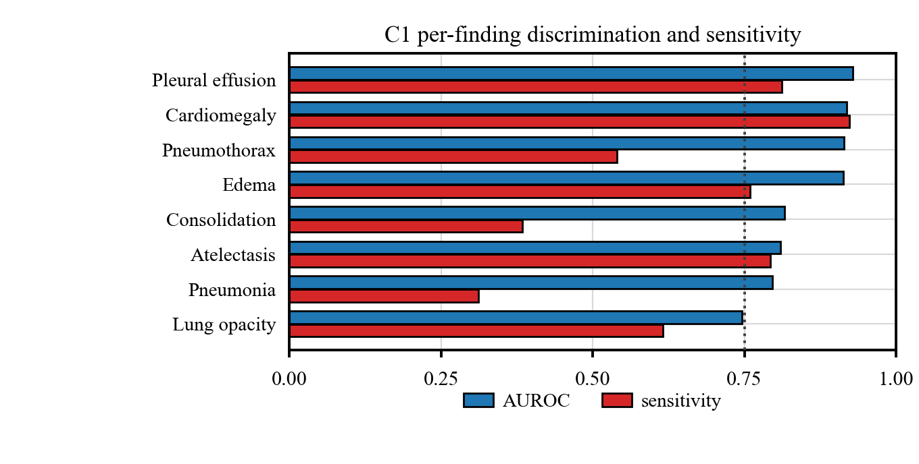
Fig. 2. C1 per-finding discrimination and sensitivity on the 4,722-image test split, ordered by AUROC. The dotted line marks 0.75.
Fig. 3 shows what the training schedule bought C2. Validation macro-AUROC rises for roughly ten epochs, peaks near epoch 19 and then drifts down by about 0.005 while the training loss keeps falling, so checkpoints are selected on validation discrimination rather than at the end of the schedule. The three seeds differ by less than the epoch-to-epoch noise, which is why we report seed variance for this component and not run-to-run stability for the others.
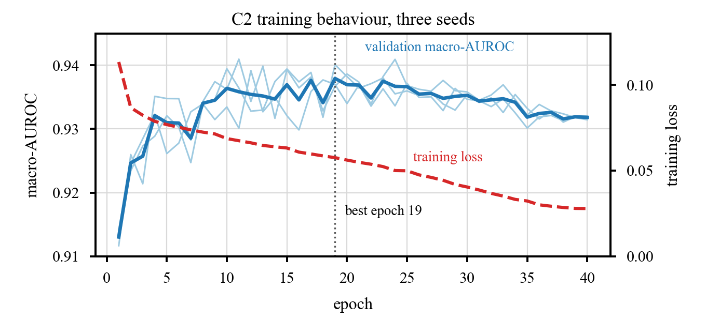
Fig. 3. C2 validation macro-AUROC and training loss over 40 epochs, three seeds. Grey lines are individual seeds, the solid line their mean.
B. What the Abstention Mechanisms Buy
Each result below is stated against a control, meaning an arm that keeps the procedure and removes the signal. Fig. 4 shows one result per component.
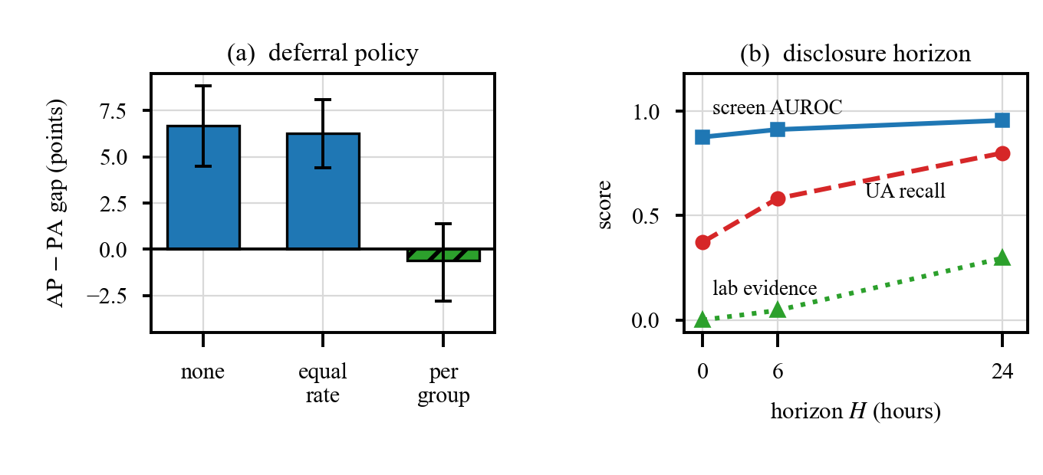
Fig. 4. (a) Accuracy gap between acquisition groups under three deferral policies, with 95 % bootstrap intervals. (b) Screen AUROC, unstable-angina recall and the share of attribution carried by laboratory features, against the disclosure horizon.
Acquisition shift. C1 scores AUROC 0.8224 on bedside images against 0.8864 on standing ones, a gap of 0.0639 [0.0491, 0.0790] in the same direction for all eight labels. Fitting the operating point per group cut the reported true-positive-rate disparity by 73.3 % with an AUROC spread of exactly zero, at no significant accuracy cost (+0.02 points, [−0.26, +0.31], McNemar mid-p 0.885). We also reimplemented the representation-side alternative [16] on our own data, backbone and split: it reached complete invariance, projection-detection AUC 0.5000, and still made the disparity 25.4 % worse at a cost of 0.0789 AUROC. Deferral behaves the same way (Fig. 4a). Deferring the same fraction of both groups leaves the 6.68-point gap at 6.28, the behaviour [21] describes; deferring per group at matched coverage closes it to −0.62 [−2.78, 1.37], a difference of 5.83 points with paired bootstrap p = 0.0004, at 85.8 % coverage overall.
Conditional validity. Fitted marginally, the conformal bound held in only 14 of 23 class-by-subgroup cells, and two violations survive Holm correction: one class at a miss rate of 0.333 against a promised 0.10 under age 50, another at 0.330 against 0.20 at age 70 and over, with adjusted p of 5.1 × 10⁻⁶ and 0.029. Refitting one threshold per subgroup [19] restored the bound in 22 of 23 cells, at the cost that every cell now needs its own positives: one with 42 cannot support a finite threshold and is reported as unattainable.
Silent corruption and open-set inputs. Simulating each of the three limb-electrode swaps on 200 test recordings, the corrupted signal passes the quality gate in 197 to 198 of them, because it is a clean recording wired wrongly; up to 87 % of diagnoses change and 7 guarantees are voided. The physiology check catches 65.5 % and 60.5 % of two swaps at 4.5 % false positives, and 4.0 % of the third, which leaves the diagnostic lead untouched. Separately, 114 recordings carry a rhythm the label space cannot express, and 113 received a bounded rule-out for a disease the model has no output unit for; the irregularity gate withholds it on 48.9 % of them. The claim is withdrawn, not the diagnosis.
Shrinkage under imbalance. On identical weights, the expansion in (6) lifted recall on the rarest class from 0.590 to 0.687, and seed averaging carried the worst class to 0.723. Selective prediction, which helped C1, failed here: at 88.4 % coverage worst-class recall fell to 0.706 while overall accuracy rose to 0.770. The uncertainty signal is fine, since accuracy on deferred studies is 0.426 against 0.770 on answered ones; the problem is geometric, in that one class occupies a 10-point interior band and abstention removes its members first.
Temporal leakage. One comorbidity column equals 1 for every positive stay and reaches AUROC 0.9200 alone; adding it back to an otherwise safe feature set moves the screen from AUROC 0.9665 to 0.9889, which is how an apparently excellent result gets manufactured. A random split puts 5,804 patients on both sides and contaminates 7,627 test rows; the patient-grouped split shares none. Under the availability contract, performance becomes a function of time (Fig. 4b): screen AUROC 0.8763, 0.9121 and 0.9560, and recall on the hardest subtype 37.3 %, 58.2 % and 80.0 % at H = 0, 6 and 24. That subtype is defined by a normal blood test, so it cannot be separated from its neighbour until the test returns. At H = 0 the laboratory channel carries exactly 0.0 % of the attribution mass, rising to 4.6 % and 29.6 %; a leaking pipeline cannot produce that pattern.
C. Turning the Same Standard on Our Own Designs
The mechanisms above were tested against controls. So were four of our own design decisions, and three came back negative. The sharpest is C2's architecture, which adds three things to a plain one-dimensional residual network. At three seeds each, compared by paired bootstrap on the untouched fold, they do not earn their 566 k parameters: the stem and attention pooling change nothing (p = 0.741), and squeeze-and-excitation on top of them costs 0.0042 macro-AUROC (p = 0.0040). Almost the whole loss sits on one class, +0.0147 AUROC without it and three times the next largest effect, and there is a mechanism rather than a coincidence: that diagnosis is read from QRS amplitude, and squeeze-and-excitation recalibrates channels by learned importance, an operation on relative amplitude across leads. The shipped model is still the worse one, because swapping it means refitting the calibrator and the conformal thresholds and re-verifying every figure.
C4's infarct-wall head is the second. With every feature it reaches AUROC 0.9074 and no per-class metric below 0.7551 on 104 test cases; removing three features parsed from the recording device's own printed interpretation costs 0.133 AUROC and drops the weakest metric to 0.6038, and those three alone reach AUROC 0.841. This is not temporal leakage, since they exist at triage, but the person who assigned the diagnosis code read the same printout, so feature and label share a source and the model largely transcribes an interpretation already in the record. Both numbers belong in any report of it. Widening the head beyond two territories was measured too: a third class is recalled in 1 case of 12 and drags the other two down with it. The remaining two ablations are quieter. C3's backbone, inherited from a benchmark, was tested against the un-factorised alternative at three matched seeds and is worth keeping, though only on the classification metrics; the first version of that test was single-seed and confounded, which we found and re-ran. C2's neural report generator beats a constant sentence and a five-string lookup on BLEU-4 by 0.054, a real gain and a small one, and preserves the classifier's findings exactly in 73.9 % of reports. Neither it nor the wall head is served.
One check of the same kind closes the loop. Research and serving code drift apart, so beside the service's 132 automated tests the radiograph endpoint was scored on 200 stratified real studies posted through the live HTTP path. Served accuracy was 0.790 [0.728, 0.841], sensitivity 0.880 [0.802, 0.930] and specificity 0.700 [0.604, 0.781], all consistent with the offline figures at 14.0 % deferred, and accuracy was 0.766 on bedside images against 0.833 on standing ones. The covariate shift reappears on real inputs through the deployed path, and the horizon contract is enforced per patient: for a single record the laboratory channel reads 0.000 % at triage.
VII. Discussion and Limitations
Across all four modalities the useful intervention sat in the decision rule, not the representation: three attempts to close the acquisition gap by changing the model failed against a null arm, while a threshold and a deferral budget conditioned on the same variable worked at no cost in ranking quality. Much of clinical reliability is therefore post-processing, which is cheap to fit, auditable and changeable without retraining.
The limitations are real. No component has external validation; each uses one dataset, or one pair, and every evaluation is retrospective. The C1 split is custom, its positive class enriched to 50.4 %, and 98.3 % of its test images fall inside the official MIMIC-CXR training split, so those numbers are not comparable with published MIMIC-CXR results; C2 keeps only codes at full likelihood and drops 21 % of PTB-XL, so the same applies there. Training variance is measured for C2 and C3 and not for the other two. The four cohorts are disjoint, so the ordering in Section III is how the components would compose clinically and not a validated end-to-end study. Subgroup coverage is partial: C1 covers the acquisition field only, C2 sex and three age bands, the C3 cohort has no demographic fields, and C4 has them but no breakdown yet. The electrode audit rests on 200 recordings, and regular out-of-scope rhythms remain silent failures. The infarct-wall head has 104 test cases, and two either way move its weakest metric across 0.75. C3 does not reach its 0.75 worst-class target. Grad-CAM is a sanity check, not evidence of localisation, its repeatability on chest radiographs measured at a structural similarity of 0.12 [27]. This is not a medical device.
VIII. Conclusion
We built a four-modality clinical decision-support system in which every component has an explicit rule for declining to answer, and every rule is measured against a control. Conditioning that rule on whatever variable actually causes the failure, an acquisition setting, a patient subgroup, a rhythm outside the label space, or the time a feature became available, beat changing the model in every case we tested and usually cost nothing in ranking quality. The same standard applied to our own design decisions returned three negative results out of four. Reducing four refusal vocabularies to one five-level field then lets client code apply a single rule everywhere. Next are external validation, multi-seed training for the two components that lack it, subgroup analysis on whatever axes each cohort supports, and a paired study on the 19,979 patients two of our cohorts share.
References
[1] R. A. Byrne et al., “2023 ESC guidelines for the management of acute coronary syndromes,” Eur. Heart J., vol. 44, no. 38, pp. 3720–3826, 2023.
[2] M. Gulati et al., “2021 AHA/ACC/ASE/CHEST/SAEM/SCCT/SCMR guideline for the evaluation and diagnosis of chest pain,” Circulation, vol. 144, no. 22, pp. e368–e454, 2021.
[3] A. E. W. Johnson et al., “MIMIC-CXR-JPG, a large publicly available database of labeled chest radiographs,” arXiv:1901.07042, 2019.
[4] Z. Liu, H. Mao, C.-Y. Wu, C. Feichtenhofer, T. Darrell, and S. Xie, “A ConvNet for the 2020s,” in Proc. IEEE/CVF Conf. Comput. Vis. Pattern Recognit. (CVPR), 2022, pp. 11976–11986.
[5] H. Yuan, Z. Yuan, R. Gan, J. Zhang, Y. Xie, and S. Yu, “BioBART: Pretraining and evaluation of a biomedical generative language model,” in Proc. BioNLP Workshop, 2022, pp. 97–109.
[6] P. Wagner et al., “PTB-XL, a large publicly available electrocardiography dataset,” Sci. Data, vol. 7, art. 154, 2020.
[7] D. Ouyang et al., “Video-based AI for beat-to-beat assessment of cardiac function,” Nature, vol. 580, pp. 252–256, 2020.
[8] D. Tran, H. Wang, L. Torresani, J. Ray, Y. LeCun, and M. Paluri, “A closer look at spatiotemporal convolutions for action recognition,” in Proc. IEEE/CVF Conf. Comput. Vis. Pattern Recognit. (CVPR), 2018, pp. 6450–6459.
[9] S. Leclerc et al., “Deep learning for segmentation using an open large-scale dataset in 2D echocardiography,” IEEE Trans. Med. Imag., vol. 38, no. 9, pp. 2198–2210, 2019.
[10] G. Ke et al., “LightGBM: A highly efficient gradient boosting decision tree,” in Proc. Adv. Neural Inf. Process. Syst. (NeurIPS), 2017, pp. 3146–3154.
[11] S. M. Lundberg and S.-I. Lee, “A unified approach to interpreting model predictions,” in Proc. Adv. Neural Inf. Process. Syst. (NeurIPS), 2017, pp. 4765–4774.
[12] A. E. W. Johnson et al., “MIMIC-IV-ED, a large, publicly available database of emergency department electronic health records,” Sci. Data, vol. 10, art. 1, 2023.
[13] R. R. Selvaraju, M. Cogswell, A. Das, R. Vedantam, D. Parikh, and D. Batra, “Grad-CAM: Visual explanations from deep networks via gradient-based localization,” in Proc. IEEE Int. Conf. Comput. Vis. (ICCV), 2017, pp. 618–626.
[14] L. Seyyed-Kalantari, G. Liu, M. McDermott, I. Y. Chen, and M. Ghassemi, “CheXclusion: Fairness gaps in deep chest X-ray classifiers,” in Proc. Pacific Symp. Biocomputing (PSB), 2021, pp. 232–243.
[15] M. Hardt, E. Price, and N. Srebro, “Equality of opportunity in supervised learning,” in Proc. Adv. Neural Inf. Process. Syst. (NIPS), 2016, pp. 3315–3323.
[16] S. C. Pereira, J. Rocha, A. Gaudio, A. Smailagic, A. Campilho, and A. M. Mendonça, “Addressing chest radiograph projection bias in deep classification models,” in Proc. Med. Imag. Deep Learn. (MIDL), PMLR, vol. 227, 2023, pp. 1199–1210.
[17] C. K. Chow, “On optimum recognition error and reject tradeoff,” IEEE Trans. Inf. Theory, vol. 16, no. 1, pp. 41–46, 1970.
[18] V. Vovk, “Conditional validity of inductive conformal predictors,” in Proc. Asian Conf. Mach. Learn. (ACML), PMLR, vol. 25, 2012, pp. 475–490.
[19] V. Vovk, D. Lindsay, I. Nouretdinov, and A. Gammerman, “Mondrian confidence machine,” Tech. Rep., 2003.
[20] C. Guo, G. Pleiss, Y. Sun, and K. Q. Weinberger, “On calibration of modern neural networks,” in Proc. Int. Conf. Mach. Learn. (ICML), 2017, pp. 1321–1330.
[21] E. Jones, S. Sagawa, P. W. Koh, A. Kumar, and P. Liang, “Selective classification can magnify disparities across groups,” in Proc. Int. Conf. Learn. Represent. (ICLR), 2021.
[22] W. Cao, V. Mirjalili, and S. Raschka, “Rank consistent ordinal regression for neural networks with application to age estimation,” Pattern Recognit. Lett., vol. 140, pp. 325–331, 2020.
[23] K. Cao, C. Wei, A. Gaidon, N. Arechiga, and T. Ma, “Learning imbalanced datasets with label-distribution-aware margin loss,” in Proc. Adv. Neural Inf. Process. Syst. (NeurIPS), 2019, pp. 1567–1578.
[24] S. Kaufman, S. Rosset, C. Perlich, and O. Stitelman, “Leakage in data mining: Formulation, detection, and avoidance,” ACM Trans. Knowl. Discovery Data, vol. 6, no. 4, art. 15, 2012.
[25] Q. McNemar, “Note on the sampling error of the difference between correlated proportions or percentages,” Psychometrika, vol. 12, no. 2, pp. 153–157, 1947.
[26] S. Holm, “A simple sequentially rejective multiple test procedure,” Scand. J. Statist., vol. 6, no. 2, pp. 65–70, 1979.
[27] N. Arun et al., “Assessing the trustworthiness of saliency maps for localizing abnormalities in medical imaging,” Radiol. Artif. Intell., vol. 3, no. 6, art. e200267, 2021.

